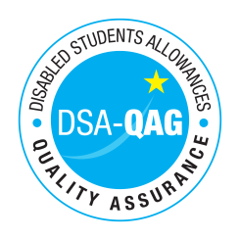
Northern School of Contemporary Dance - NMH Rates

Period covered - 01/04/2017 through to 31/03/2018

The table below shows NMH rates.

Note: NMH Support Rates shown per hour in the table below.
 | Standard Rate (in-person) |  |  | Distance Learning only (in-person, in-home |  |  | Remote Delivery (e.g. Facetime/Skype or similar) Only
Band 4 Specialist Access and Learning Facilitators
Specialist Mentor – Mental Health | £55 | NA | £55 | NA | NA | NA | £55 | NA | £55
Specialist 1:1 Study Skills Support - SpLD | £55 | NA | £55 | NA | NA | NA | £55 | NA | £55

