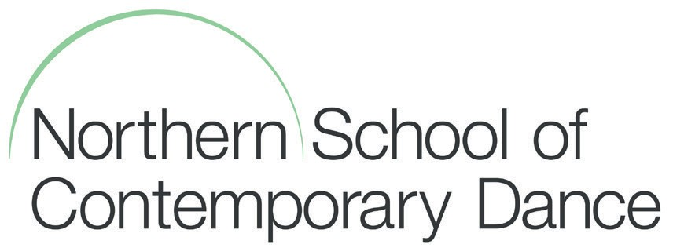
98 Chapeltown Road Leeds LS7 4BH West Yorkshire United Kingdom
T: +44 (0) 113 219 3000
E: info@nscd.ac.uk www.nscd.ac.uk

Foundation Course Free School Meal Application Form 2017-18
If you are aged between 16 and 18 on the 31st August 2017, you may be eligible for free school meals.
If you are aged between 19 and 25 and are subject to a Learning Difficulty Assessment (LDA) or Education
Health and Care Plan (EHC Plan) you may also be entitled to a free school meal if you meet the eligibility
criteria.

NOTE: You will not qualify for free school meals if your household receives Working Tax Credit.

Your Details:
Name ……………………………………………………………………………………………………………………………………………
Address ……………………………………………………………………………………………………………………………………………
……………………………………………………………………………………………………………………………………………
……………………………………………………………………………………………………………………………………………
DoB ……………………………………………………………………………………………………………………………………………
NI Number ……………………………………………………………………………………………………………………………………………
Telephone ……………………………………………………………………………………………………………………………………………

I would like to apply for free school meals for the following child:
Name ……………………………………………………………………………………………………………………………………………
DoB ……………………………………………………………………………………………………………………………………………

Your Benefits
Please answer the following questions: Yes No
I receive Income Support or Income Based Job Seekers Allowance □ □
I receive the Guarantee Credit element of State Pension Credit □ □
I am the parent/guardian of the child and receive child benefit for them □ □
I receive support under part VI of the Immigration and Asylum Act 1999 □ □
I receive Child Tax Credit only and my annual income does not exceed £16190 □ □

Note: You will need to provide your Benefit award notification to confirm your entitlement.

Your Signature ……………………………………………………………………………………………………………………………………………
Date ……………………………………………………………………………………………………………………………………………

