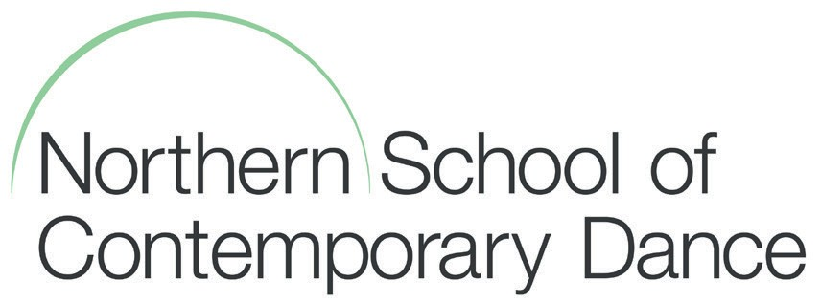
Receptionist
Further Information

Northern School of Contemporary Dance is one of the leading dance training institutions in the UK and affiliated to the Conservatoire for Dance and Drama (CDD). The School is a College of Higher Education offering full time undergraduate, post graduate and Access courses to around 250 full time students.

As well as our full time students the School hosts a wide and varied number of community dance groups as well as being a Centre for Advanced Training for young people. Out of term, the School hosts Easter and Summer Schools. The School is an incredibly busy, vibrant and dynamic learning environment where in a busy week over one thousand visitors could use our facilities in one way or another.

The School is situated in the Chapeltown area of Leeds just outside the city centre and comprises 8 dance studios, offices and teaching areas, a fitness centre plus the bar and café area. Attached to the building is the Riley Theatre, a 250 capacity professional dance theatre managed by NSCD hosting international, national and student performances throughout the year for the student population and wider community.

The Schools opening hours are 9.00am to 9.00pm Monday to Friday and 9.00am to 5.00pm Saturday and Sunday during term time. Out of term time, opening hours are slightly reduced.

